Simple, beginner-friendly way and explain:
- What projects/work you did
- What tools were used
- How each tool works (with easy examples)

👉 GCP Data Engineer
Your main job:
- Collect data from different sources
- Process it (clean, transform)
- Store it properly
- Make it ready for analytics (reports, dashboards)
This is called a Data Pipeline / ETL process

🔁 What Projects You Worked On (Simplified)
Project Type 1: Data Ingestion Pipelines
👉 Moving data from systems like SAP, Oracle → Cloud
Example:
- Data from SAP system → stored in GCS → processed → stored in BigQuery

Project Type 2: ETL/ELT Pipelines
👉 Transforming data
Example:
- Raw sales data → cleaned → aggregated → used for reports

Project Type 3: Migration to Cloud (GCP)
👉 Moving old systems → Google Cloud
Example:
- Old server database → BigQuery

Project Type 4: Real-Time Data Processing
👉 Streaming data using Pub/Sub
Example:
- Live transaction data → processed instantly → dashboard updates

🛠️ Tools Used in Your Projects (Detailed + Simple Examples)
Now let’s explain each important tool you used:
☁️ 1. Google Cloud Storage (GCS)
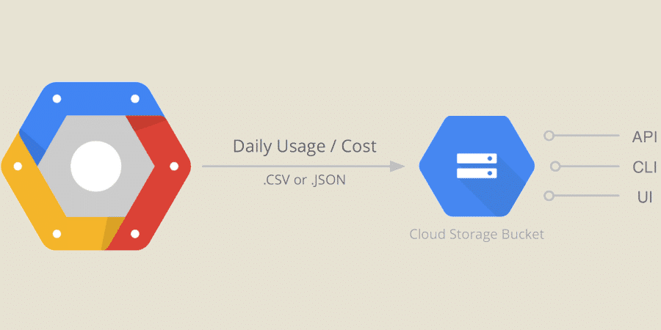
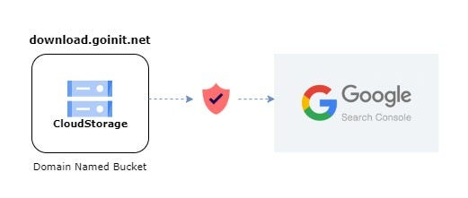
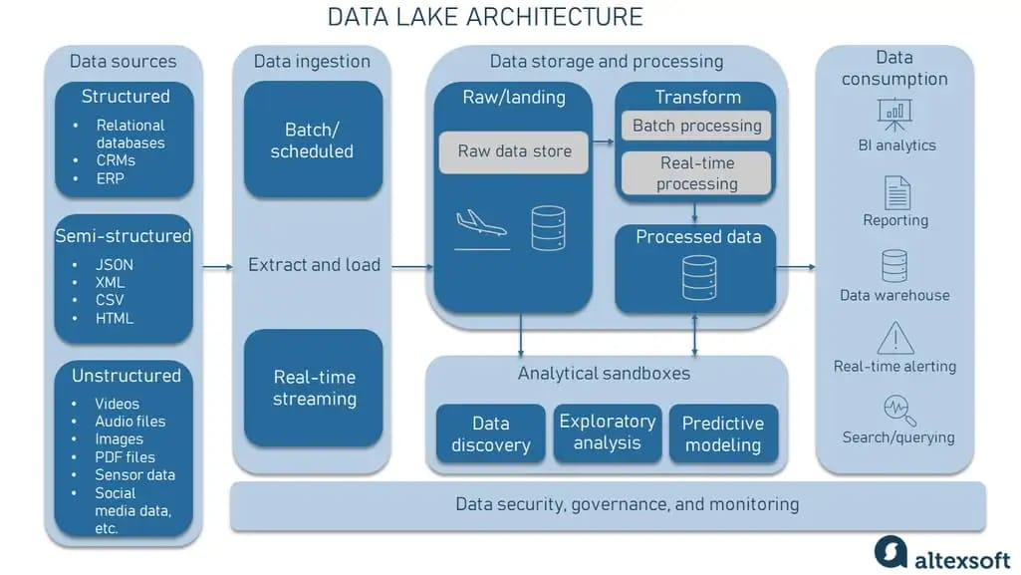
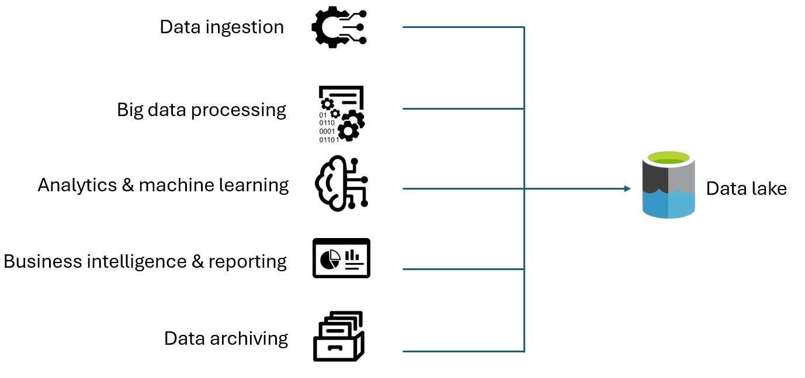

👉 Acts like a data lake (storage place)
What it does:
- Stores raw data (CSV, JSON, etc.)
Example:
- You upload a file:

- sales_data.csv → stored in GCS bucket

📊 2. BigQuery
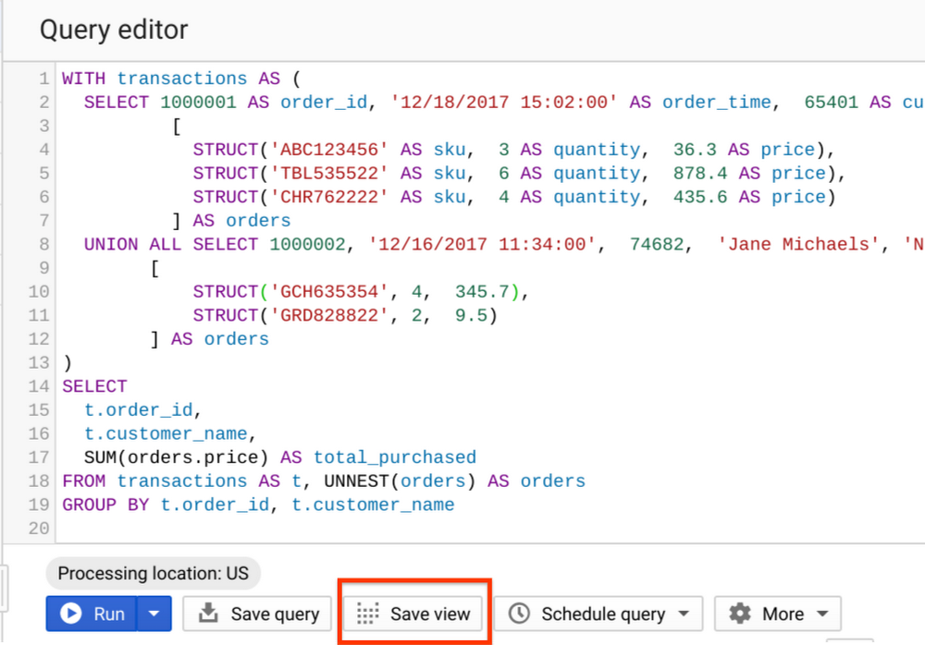
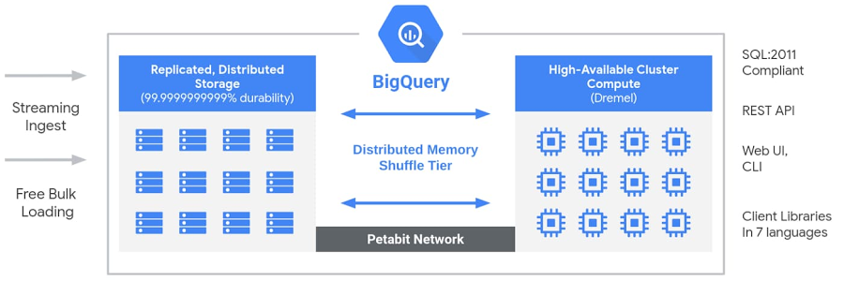
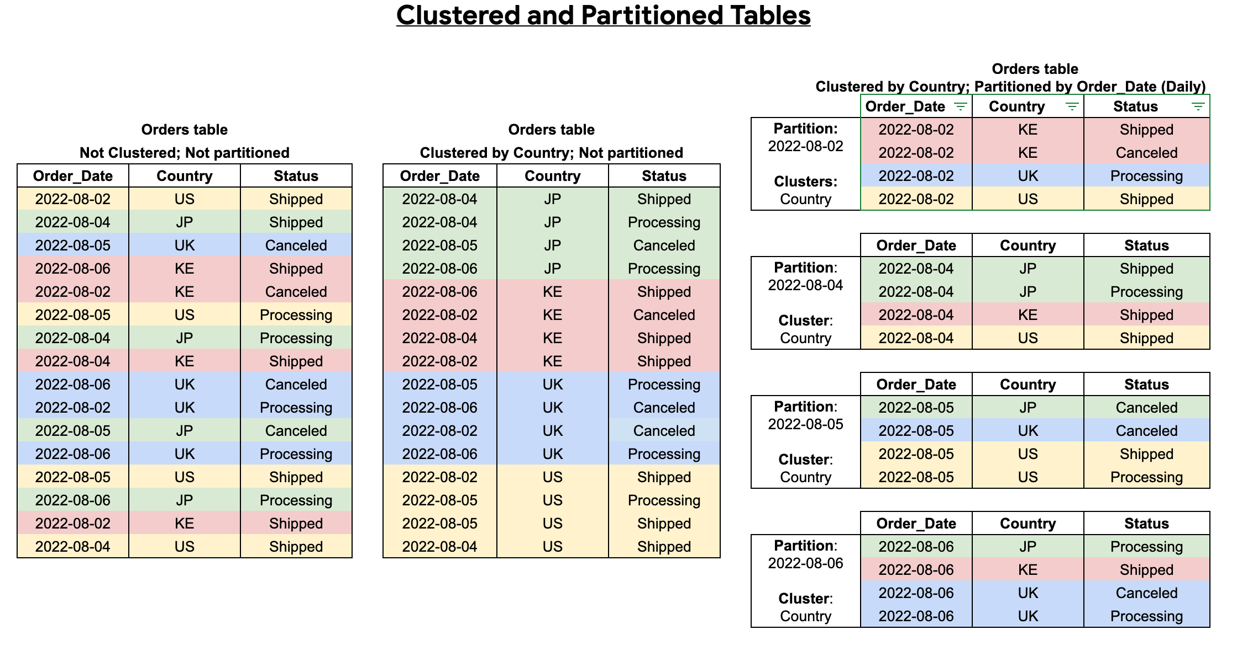
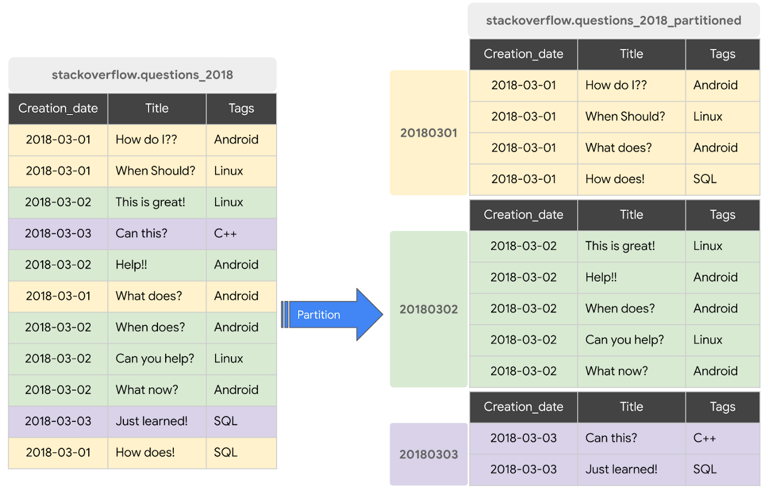
👉 A data warehouse (for fast querying)
What it does:
- Stores processed data
- Runs SQL queries very fast
Example:
- SQL:
SELECT SUM(sales) FROM sales_table;

🔄 3. Dataflow (Apache Beam)
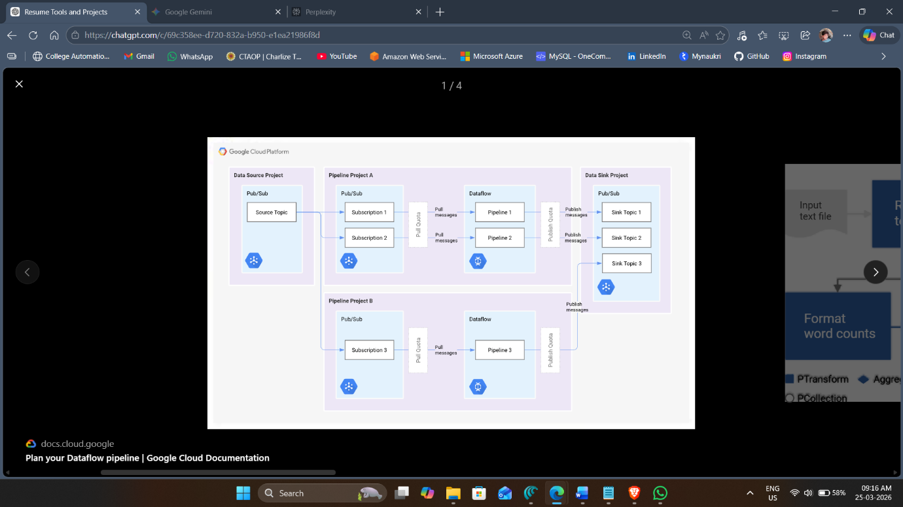
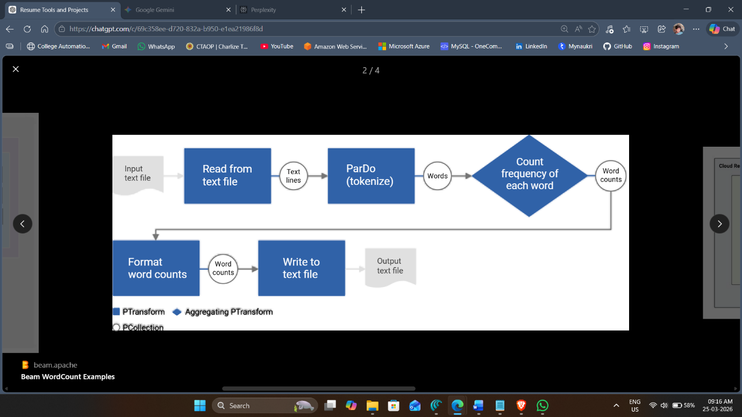
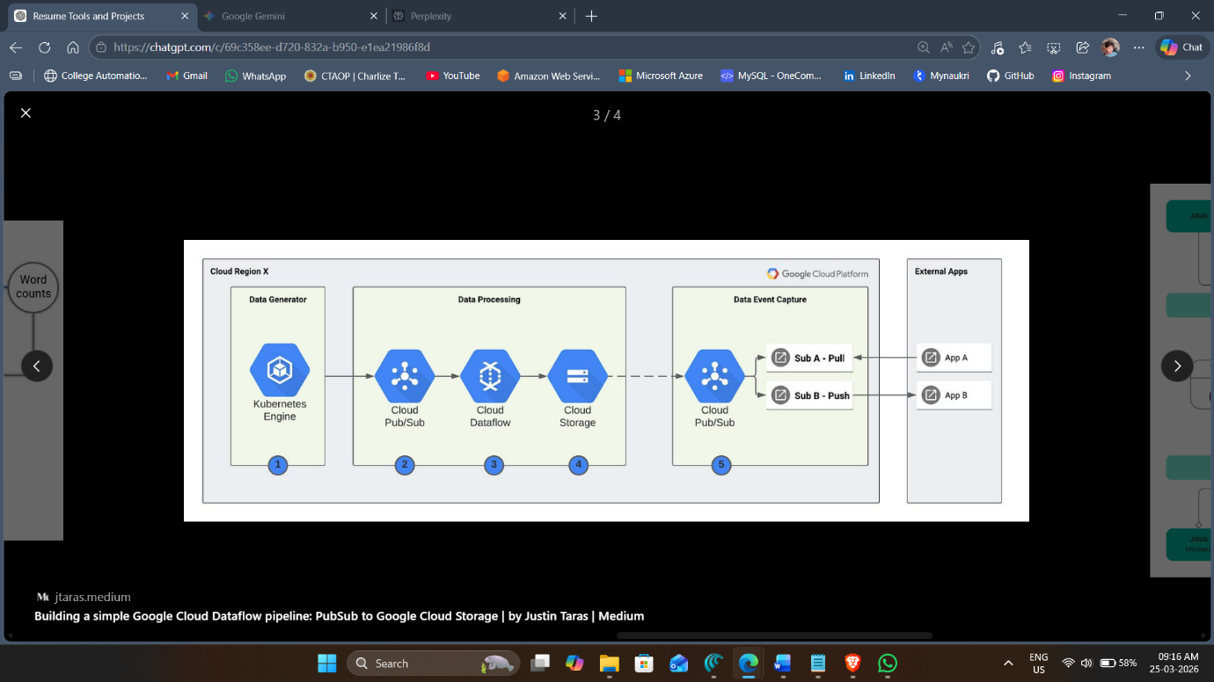
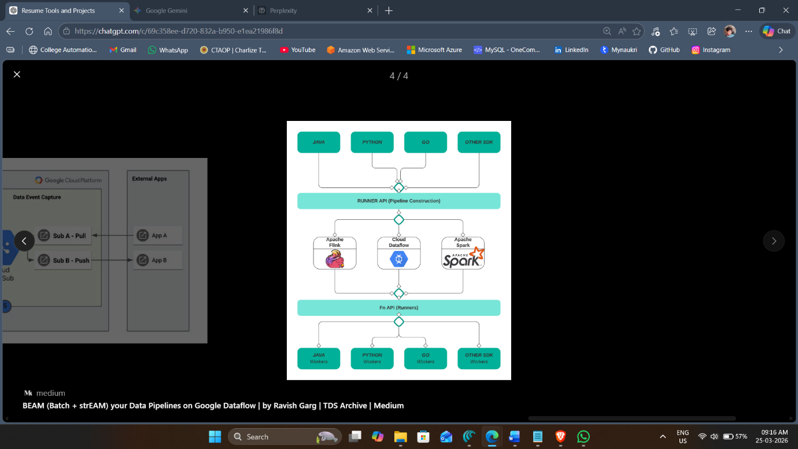
👉 Used for processing data (ETL)
What it does:
- Reads data
- Transforms it
- Writes output
Example:
- Read CSV → remove null values → write to BigQuery

🔔 4. Pub/Sub
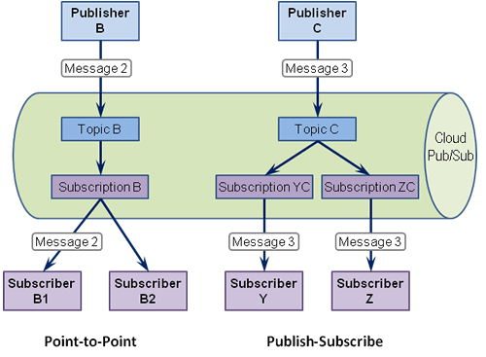
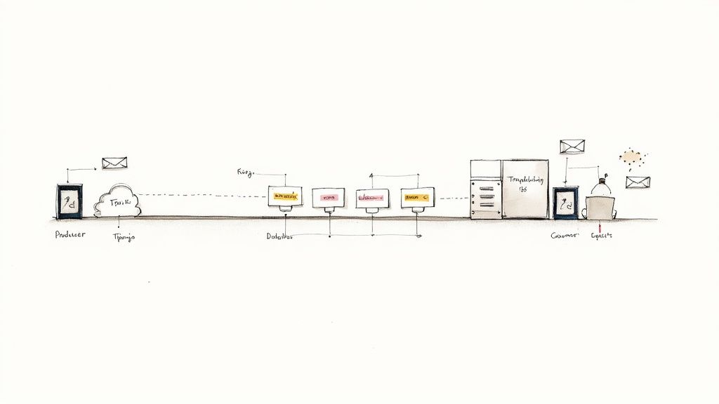
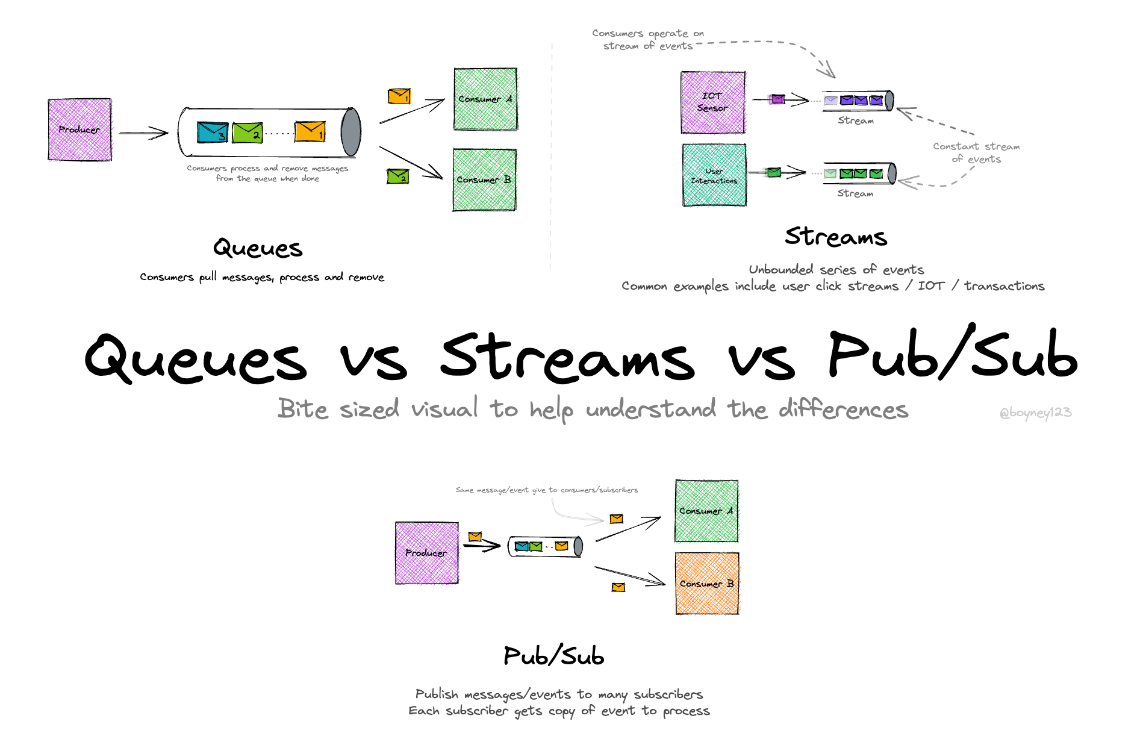
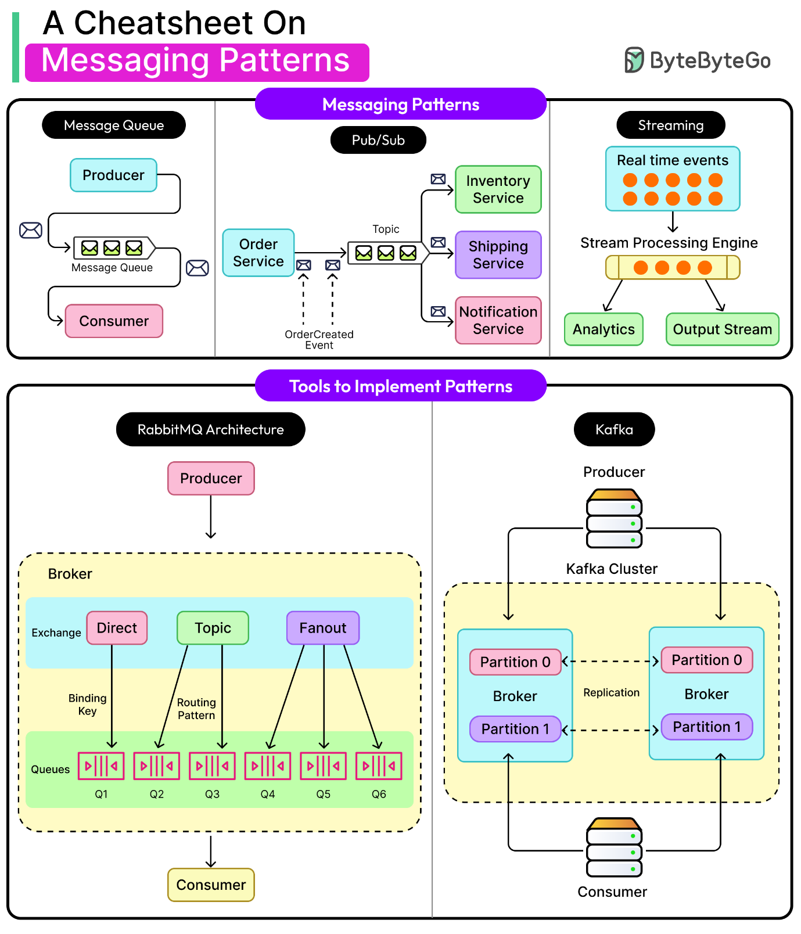
👉 Messaging system (for real-time data)
What it does:
- Sends data instantly between systems
Example:
- App sends message → Pub/Sub → Dataflow processes it

⏰ 5. Composer (Apache Airflow)
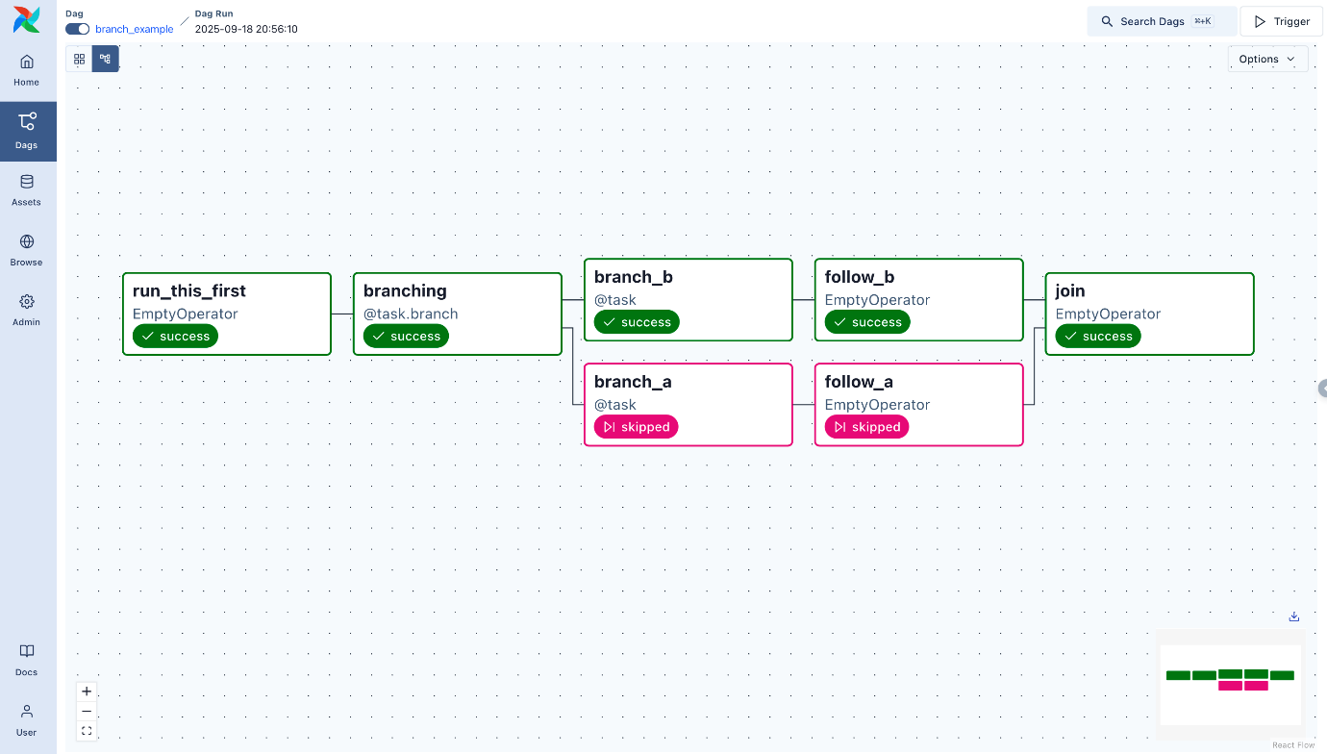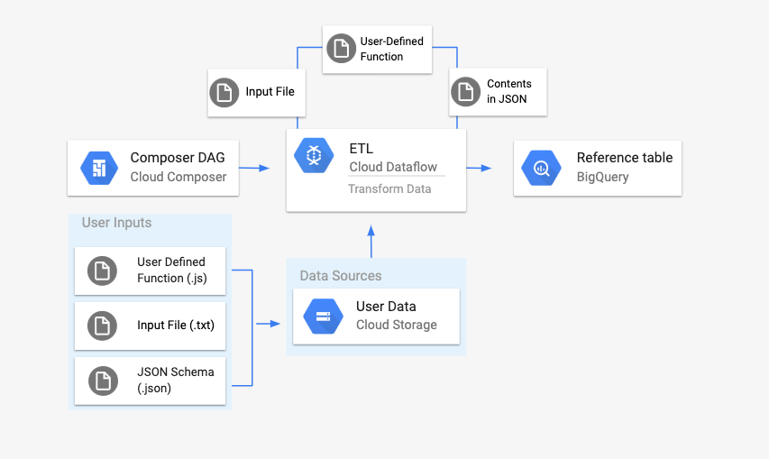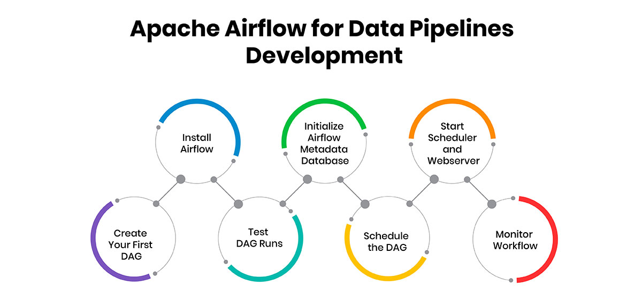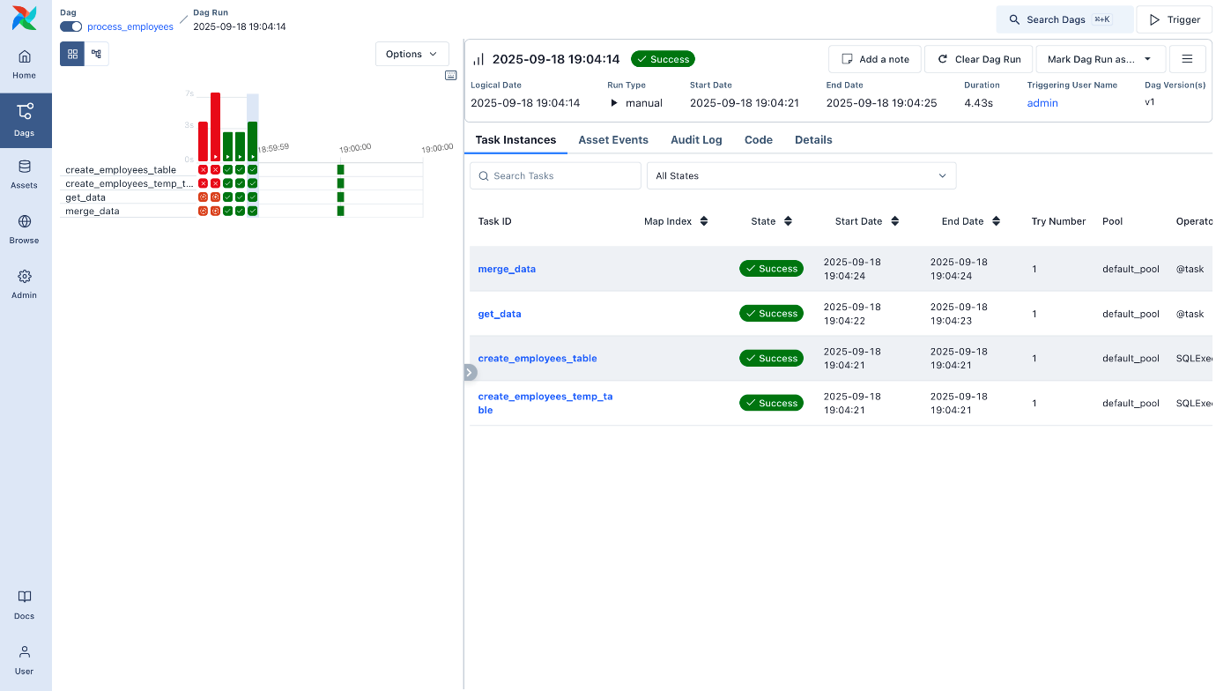
👉 Workflow scheduler
What it does:
- Runs pipelines automatically
Example:
Every day at 2 AM:
→ Load data
→ Process data
→ Store in BigQuery
⚡ 6. Data Fusion
👉 GUI-based ETL tool
What it does:
- Drag & drop pipelines (no heavy coding)
Example:
- Drag source → transformation → destination

🔥 7. Dataproc (Apache Spark)
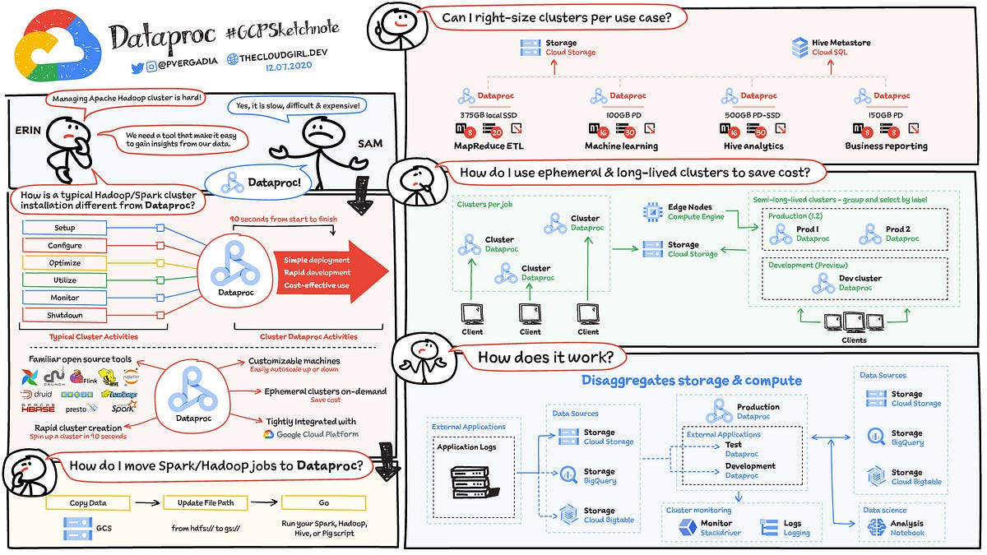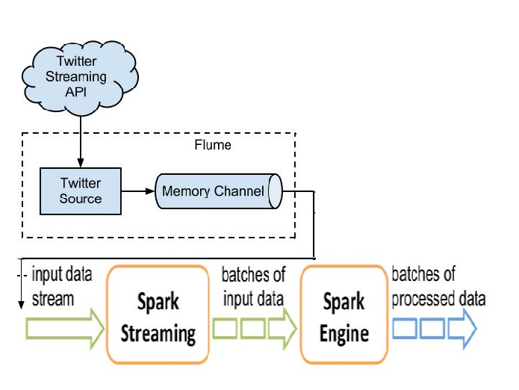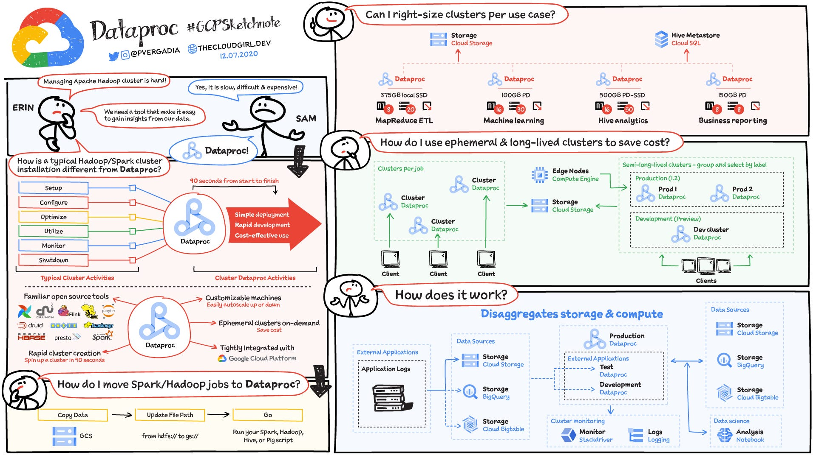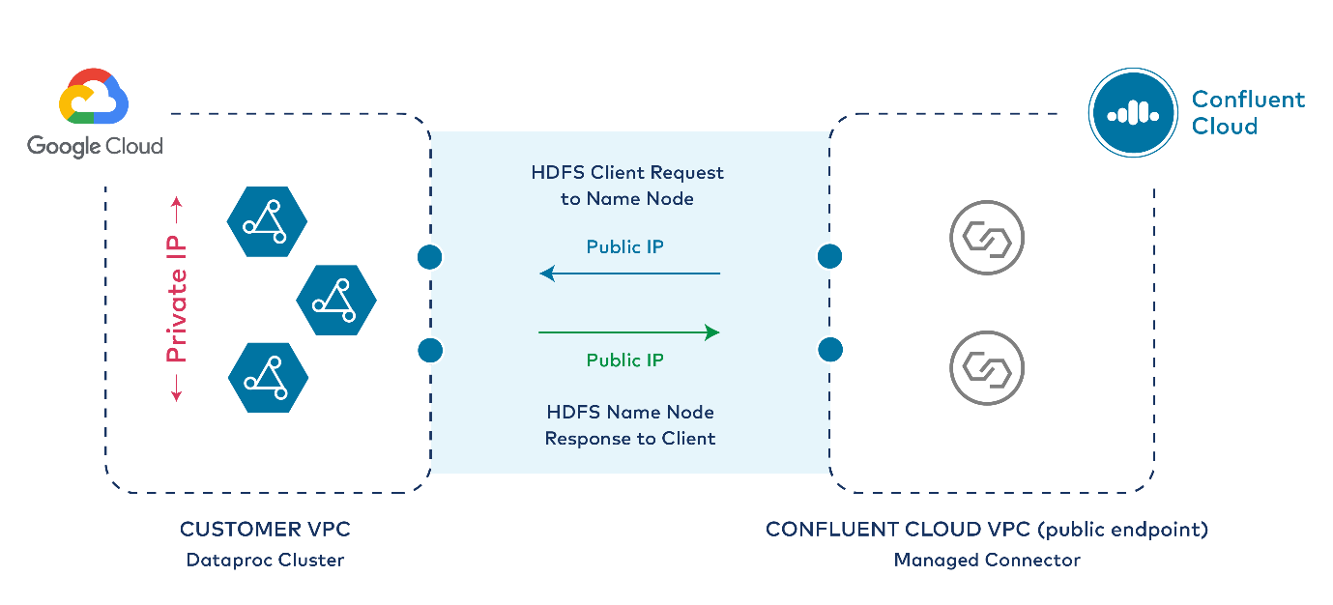
👉 Big data processing using Spark
What it does:
- Handles very large datasets
Example:
- Python:
df = spark.read.csv("data.csv")
df.filter(df.age > 18)

🐍 8. Python
👉 Main programming language
What it does:
- Automation
- Data processing
Example:
- Python:
print("Hello Data Engineer")

🧱 9. Terraform (Infrastructure as Code)
👉 Automates cloud setup
What it does:
- Creates resources automatically
Example:
- Create BigQuery dataset using code

🔧 10. Git / GitHub
👉 Version control
What it does:
- Tracks code changes
Example:
- Save versions of pipeline code

📊 11. Visualization Tools
- Power BI
- Looker
- Qlik Sense
👉 Used for dashboards
Example:
- Sales dashboard with charts

🔗 How Everything Connects (Simple Flow)

Source (SAP / Oracle)
↓
GCS (storage)
↓
Dataflow (processing)
↓
BigQuery (warehouse)
↓
Dashboard (Power BI / Looker)

🧠 Simple Real-Life Example
Imagine:
👉 Amazon-like system
- User buys product
- Data sent via Pub/Sub
- Dataflow processes it
- Stored in BigQuery
- Dashboard shows sales
✅ Summary (Very Simple)
You mainly worked on:
- Building data pipelines
- Moving data to cloud (GCP)
- Processing data using Dataflow/Spark
- Storing in BigQuery
- Automating using Composer
- Managing using Terraform & Git

